Electronic Commerce Project 1
Working in teams, the students create a Web presence for a client of their choice. The project will require demonstrated
competencies in requirements analysis,
project planning and management, applica- tion of HTML, VBScript programming, use of Web development tools like FrontPage
and integration of reusable components (ActiveX). The project will involve the
design and implementation of an Access 97 relational database and the connection of the database to the Web for both collection and publication of information. This project will emphasize client-side programming in an Internet/Intranet application.
Object-Oriented Programming in Java
This module introduces you to the Java language as a tool for network computing. You will enhance previously developed Web applications with Java Scripting language (JavaScript or Jscript) as Java applets. Using electronic commerce as the learning context, we shall explore Java system features, distri- bution of executable content using applets, platform independence issues, security
measures, Java language specifics, object- oriented programming, as well as core and
extension libraries. You will also learn to use JDBC to connect Web clients to databases and to perform object-oriented analysis and design for a business application.
Electronic Commerce Project 4
In this project, the students will convert and enhance an Explorer™-based Internet application with Java object-oriented technology. This will allow the application to run in other browsers such as Netscape™ Navigator. The project will involve conversion project planning, redesigning applications, converting VB codes to Java scripts and applets, and converting ODBC access to JDBC database access.
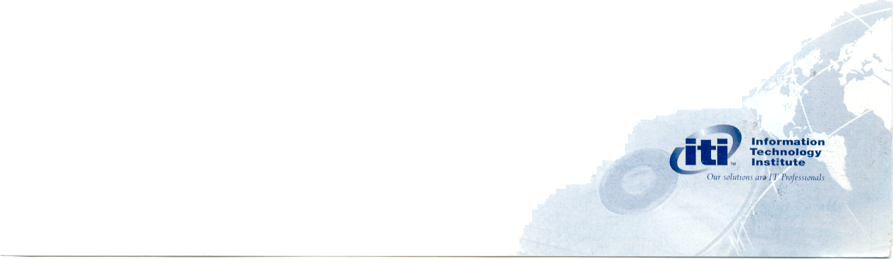


Fundamentals of Network Computing Using the Internet as the learning context, this module introduces the students to all fundamental concepts of IT. This problem based module will cover the basic tools of information technology and you will use the Internet as a research tool. You will learn how to design and construct a basic Web site using HTML and FrontPage as well as using both HTML and VBScript to develop client-side programs for data validation, calculation, special effects and more. You will learn how to incorporate the use of ActiveX and Java applets into the Web pages you develop. You will design and construct a relational data- base using Access™ 97 and learn how to write client programs to query the database over the Internet using HTML, VBScript, and FrontPage.
Network Computing Software Development using Visual Basic™ 5
In this intensive systems development module, you will learn how to design Internet aware business applications for Win32™ architecture. You will learn to use VB5, VBA, Office™ 97, ISAPI and Visual InterDev to develop server side programs for guest books, form processing, reports, mail merge and more. You will learn how to install and configure an MIS package software and connect this system to an Internet/Intranet application using VB5 as the Common Gateway Interface (CGI). You will be encouraged to prepare to write the Visual Basic™ 5 MCP exam.
Oracle™ 8 Client/Server Database Programming Using Oracle™ Official Curriculum, this course will help you understand how Oracle™ tools and methodologies can be used to fulfill real- world business information requirements. You will learn to design and create database structures to store, retrieve, update and display data in a relational database, create sharable PL/SQL blocks of application code and use Oracle™ Procedure Builder to develop and debug PL/SQL programs.
Windows Operating Systems and Network Computing Implementation
This practical hands-on module offers you the opportunity to learn how to build a Pentium server from components and install and configure a Windows NTTM server. You will learn how to connect the server to the Internet using TCP/IP and install and configure Microsoft Internet Information Server (IIS). You will install the Web client/ server applications developed in the previous modules and implement Web security using Secure Socket Layer (SSL). Using Microsoft FrontPage™, you will administer a Web site.
Electronic Commerce Project 2
This project will build upon the work accomplished in the previous project. The students will build server-side processing applications for an Internet/Intranet application. The project will require demon- strated competencies in using the Visual Basic family of tools (VBS, VBA, VBScript, Active Server page) in a network computing environment. The project will also require access to backend databases using a number of different data access methods. Students will be introduced to Microsoft Solutions Framework method of project management.
Oracle™ 8 Client/Server Database Administration
Using Oracle™ Official Curriculum, you will learn to work with a database, to add users, manage data, expand the size of the database and implement basic security and data integrity measures. You will also learn how to manage logical and physical storage structures and manage access to data by granting privileges to individual users.
Electronic Commerce Project 3
This project will concern the physical implementation of previously developed solutions. Students, working in teams, will build and configure a Windows NT™ server to host the applications developed in E-Commerce Projects 1 and 2. They will configure TCP/IP, the Microsoft Internet Information (IIS) server, Secure Socket Layer (SSL) and other necessary security measures to host the solution.
Oracle™ 8 Developer/2000 Application
Development
You will build and test an interactive application consisting of one or more Developer/2000 Forms and Reports modules. Working in a Graphical User Interface (GUI) development environment, you will build a complete forms application using Developer/2000. You will also learn to retrieve, display and format data in numerous report styles.
Access to ITI's Computer Based Training Library enables our students to acquire IT knowledge and skills in addition to our standard curriculum.

